CODE CHALLENGE
[ Big Data ]
Date: [ ] Session: [ ] Duration: [ 3 Hrs ] Total Marks: [ 100 ]

Instructions:

1. Open Book

2. CDH 5.13 onwards can be used

3. Case Study for Analysis is Aadhar Card Data. It is available in Dataset folder on SourceForge or can be downloaded (https://bit.ly/aadharcodechallenge).

4. Inference has to be based on data definition as below.

5. Hive / Spark to be used for solving questions (1-18) related to the case study.
Question 19 to be attempted through sqoop.Question 20 to be attempted through
HBase & Hive.

6. Marks are allocated as follows -:

• Questions (1-18)
• 10 Marks for executing question through Spark Scala Maven Project on Lab VM and downloading the result files or taking screenshots

• 9 Marks for executing question through Spark Scala Shell on Lab VM and downloading the result files or taking screenshots

• 8 Marks for executing question through Hive on Lab VM and downloading the result files or taking screenshots

• 7 Marks for only preparing the code (No Execution)

• 5 Marks for only preparing pseudo plan (No actual Code / Execution)

• Question 19 & 20 carry 10 Marks each. Code preparation is the only expected step.

7. Candidate is expected to attempt 100 Marks through combination of choices as above.

Page 1 of 3
Data Definition:

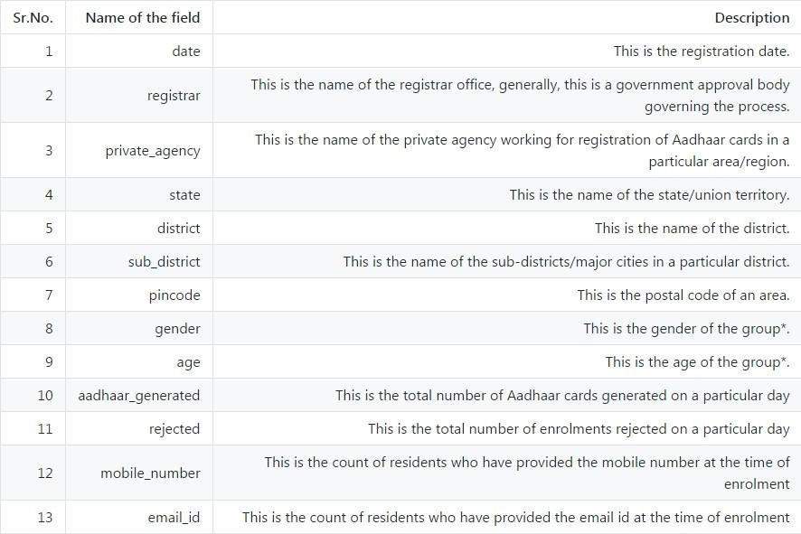

(*: explained in the example below).

Note: The dataset does not contain the headers. You should use the header names in the order as mentioned above.

You can understand the data dictionary better by the following example: A row with data –
20150420, Allahabad Bank, A-Onerealtors Pvt Ltd, Uttar Pradesh, Ambedkar Nagar, Akbarpur, 224155, F, 15, 5, 0, 0, 4

Indicates that

• On 20 Apr 2014 (date), for A-Onerealtors Pvt Ltd (private_agency) registered with Allahabad Bank (registrar) at PIN code 224155, Akbarpur (sub_district), Ambedkar Nagar (district), Uttar Pradesh (state)
• Among the group of women aged 15
• There were 5 Aadhar numbers generated and 0 were rejected
• Out of the 5 that applied, none had an email ID and 4 had mobile numbers

Page 2 of 3
Questions:

1. Load the data into HDFS, Hive Managed table, Hive External table and Spark DataFrame.Capture the screenshot of the view/result of the top 25 rows from each individual store (HDFS, Hive – Managed/External and Spark DataFrame).
2. Find the count and names of registrars.
3. Find the number of states, districts in each state and sub-districts in each district.
4. Find the number of males and females in each state.
5. Find out the names of private agencies for each state.
6. Find out the number of private agencies for each state.
7. Find top 3 states generating most number of Aadhaar cards.
8. Find top 3 private agencies generating the most number of Aadhar cards.
9. Find the number of residents providing email, mobile number (Hint: consider non- zero values.)
10. Find top 3 districts where enrolment numbers are maximum.
11. Find the no. of Aadhaar cards generated in each state.
12. Find the number of unique pincodes in the data.
13. Find the number of Aadhaar registrations rejected in Uttar Pradesh and
Maharashtra.
14. The top 3 states where the percentage of Aadhaar cards being generated for males is the highest.
15. In each of these 3 states, identify the top 3 districts where the percentage of
Aadhaar cards being rejected for females is the highest.
16. The top 3 states where the percentage of Aadhaar cards being generated for females is the highest.
17. In each of these 3 states, identify the top 3 districts where the percentage of
Aadhaar cards being rejected for males is the highest.
18. The summary of the acceptance percentage of all the Aadhaar cards applications by bucketing the age group into 10 buckets.
----------------------------------------------------------------------------------------------------------------
19. Suppose there is a mysql server with
a. IP - 10.10.10.100, username - mysql, password - mysql123. b. This has a database FinanceDB.
c. Prepare an ETL command to retrieve data from table CustTrans for all records generated after CustTransId 50000 using 5 mappers. Only columns CustTransId, Quantity, Amount are required. Also we have been told that the data has to be maintained for archive purpose only. For security purposes, avoid providing password...can be entered at execution time.
----------------------------------------------------------------------------------------------------------------
20. Imagine a Hospital Management System.
a. Patient data has to be saved under three distinct categories, Personal Details, Medical History, Diagnosis & tests conducted
b. Prepare a schema for storing data and enter two records with different attributes.
c. Reports and querying should happen through sql on generic columns.Make sure the same can be done.

Page 3 of 3

